Viterbi Tube Car

Subject: Mechanical Engineering, Electrical Engineering  Related Subjects: | Grade Level(s):  Length of Lesson: 16 weeks | Type: Inquiry / Design / Project  Keywords:

Lesson Overview
In the Viterbi Tube Car project, students will build on their existing knowledge of basic math and science
to gain an understanding of engineering concepts.
Math: In building the car, students will accurately measure car components lengths to within 1/16" and
angles to within 1 degree. Students will determine necessary lengths of components such as chassis size,
axle length from known quantities such as tube length, width and dowel width.
Science: Students determine optimal size of inner diameter of the wheel to reduce friction from the
axle. Students will use simple machines and mechanical advantage to motorize the tube car.
Engineering: Students will assemble components into to a car that maximizes rollability and accuracy
while minimizing weight and friction. Students will create and layout simple circuits to control the
motorized car speed and direction. Students will incorporate a solar cell and control switch into the car
design to serve as an alternate power source. After the Arduino board is added, students will redesign
car to be able to drive and turn in reverse. Students will mount touch sensors to car for autonomous
driving
Technology: Using an Arduino board, photocell, circuit board and an H-Bridge motor driver, students will
design, create and program light sensing control circuit that switches power to the solar cell when
sufficient light for power exists. Students will also create an autonomous control circuit that allows the
Tube car to be programmed to follow a pre-determined path. Students will add sensors to Tube car to
add intelligence sufficient for Tube car to become an autonomous robot

Lesson Focus
Each student will create a chassis, axles and wheels. Students will then test cars for distance and ability to roll straight.

Lesson Objective(s) | 1. Accurately measure, cut and assemble components of a vehicle that will roll in a straight line  down an inclined plane (math and science).  2. Create an electric circuit using a motor, switch and battery and then use the motor circuit to  generate locomotion for a vehicle (science and engineering).  3. Design alternative fuel motorized vehicles by adding a solar cell as a power source (engineering)  4. Use coding and circuit design to create an autonomous vehicle controlled by an Arduino board  (technology)

Lesson Timing

Week 1 | Create and test Ramp Racer
Week 2 | Modify and customize Ramp Racer
Week 3 | Add motors and batteries to create Tube Car
Week 4 | Test, modify and optimize Tube Car
Week 5 | Add Solar Cell and re-wire to create Hybrid Car
Week 6 | Create moveable mount for solar cell to adjust in order to capture maximum  sunlight
Week 7 | Test, modify and optimize Hybrid Car
Week 8 | Learn about Arduino capabilities
Week 9 | Inventor’s Kit Activities Circuit #1, #2,
Week 10 | Inventor’s Kit Activities #5, #6, #9, #10,#12
Week 11 | Inventor’s Kit Activities #9, #10,#12
Week 12 | Inventor’s Kit Activities #12
Week 13 | Program and integrate Arduino into Tube Car
Week 14 | Program and integrate Arduino into Tube Car
Week 15 | Program and integrate Arduino into Tube Car
Week 16 | Test, modify and optimize Arduino-Hybrid Tube Car

Materials | Ramp Racer  - • 1 roll Masking Tape  - • 1 Hacksaw  - • 1 –utility knife  - • 20 Pushpins  - • 15 - 3/8” x36 Dowel  - • 24- 1⁄4” dowel  - • 2 sheets 20”x30” Foam board  - • Scissors (not provided)  - • Pencil (not provided)  - • 240 Rubber bands
Instructor Prep | - Step 1
Related Resources | - https://learn.sparkfun.com/tutorials/what-is-an-arduino  - https://learn.sparkfun.com/tutorials/installing-arduino-ide  - https://learn.sparkfun.com/tutorials/how-to-use-a-breadboard  - https://learn.sparkfun.com/tutorials/redboard-hookup-guide  - https://cdn.sparkfun.com/datasheets/Kits/RedBoard_SIK_3.2.pdf  - https://opensourcehardwaregroup.com/thearduinocourse/  - https://www.slideshare.net/xxahmedsakrxx/introduction-to-arduino-16634116

Lesson Plan

Introduction
Motion

Newton’s laws of motion:
– If something is moving, it will keep on moving unless some force causes it to stop moving
– If something isn’t moving, it will stay that way unless some force causes it to move
– For every action there is an equal and opposite reaction

Rollability

• Spinning ease –
– If the wheels turn easily, the vehicle will travel farther and faster.
– How easily do the wheels turn if you spin them by hand? If you roll the vehicle on a surface? Relate ease of moving of axle to ease of movement of arm. Restriction in movement like arthritis is similar to restriction of movement of wheels

• Alignment– Are all of the wheels lined to roll straight?
• Traction – Does the wheel grip the surface when a lot of force is applied?

Momentum is how we measure the motion of an object. We use the symbol p to represent it; p = m x v. Momentum is equal to the mass (sometimes thought of as weight) of an object times its velocity (sometimes thought of as speed)

Friction is a force that slows objects down or keeps them from speeding up. It can be thought of as a force that causes objects to “stick” to each other when objects slide by each other

Torque occurs when a force is used to rotate or turn something. T = f x d, where f is the force and d is the distance. Distance is the length from the place where force is applied to the axis of rotation. The greater the force, the greater the torque. Also, the greater the distance from the axis, the greater the torque.

A series circuit is formed when an electrical source (battery) is connected to an object (motor, light...) which
is connected to a switch which is connected back to the battery. When the switch is off, the circuit is open and
electricity can’t flow. When the switch is on, the circuit is closed and electricity can flow.

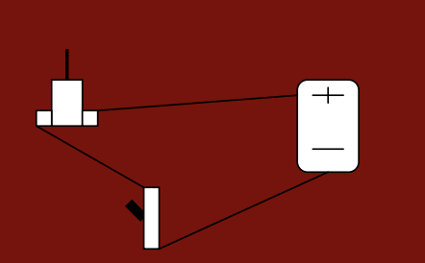
A Flowchart is a tool that graphically represents steps of a process. The Flowchart helps you analyze the number of steps and the time required for each step, to detect bottlenecks, unnecessary steps, repetitions, and other obstacles.

Different symbols are used in a Flowchart to indicate the different types of actions in the process:
• a circle for the beginning or end of the process
• a rectangle for a step in the process (activities)
• a diamond for the decision points
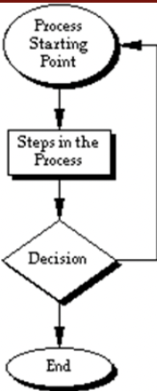
How to create a Flowchart:

1. Observe for a few repetitions the process you will be charting. Write down all the steps taken and decisions made in the process.
2. Mark the path of the Flowchart from the beginning to the end by connecting all the rectangles (activities) and diamonds (decision points).
3. Return to the beginning of the path and repeat Step 2 for any paths that branch off from the main path (at the decision points).
4. Record the last step at the bottom of the page, draw a circle around it, and connect the primary path and any branching paths to the last step.
5. Review for accuracy.

Procedure

Ramp Racer
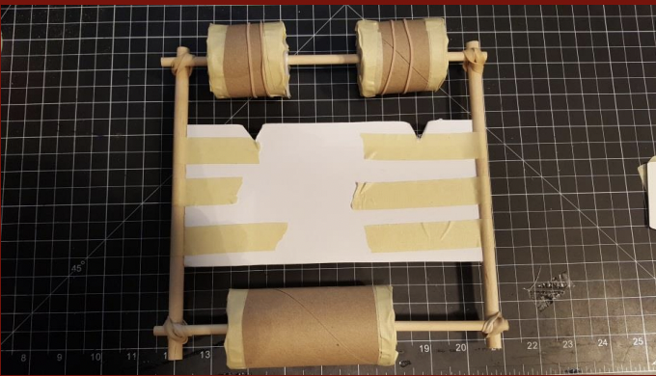

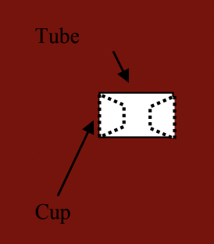
• Using the tube, draw circle 6 circles on index cards.
• Cut out the 6 circles
• Cut a tube in half
• Cut one of the halves in half creating quarter tubes
• Poke holes in the center of 6 cups with a sharpened pencil large enough for 3/16” dowel
• Insert a cup into each side of all three of the tubes

• Cut 2-3/16” dowels about 9” long.
• Insert 1 3/16” dowel through holes of both quarter tubes (this is the rear- axle)
• Insert 1 3/16” dowel through holes the half tube (this is the front- axle)

• Adjust cups with dowel inserted so that tube spins straight
• Draw a line around the cups at the lip of the tube to mark the location where cups
are to be cut

• Remove cups from tubes
• Trim the cups to be along the lines you drew
• Insert a cup into each side of all three of the tubes
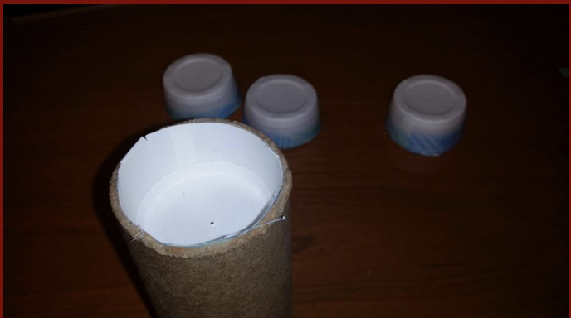
• Tape the cups in place
• Insert a dowel into a tube through the holes in the cup
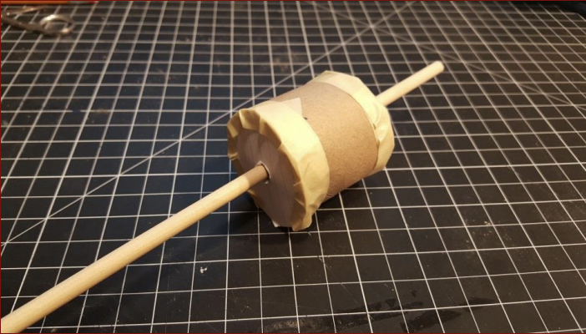
• Slide an index card circle over one end of the dowel and tape to the tube
• Slide another index card circle over the other end of the dowel and tape to the other end of the tube
• Repeat for other two tube pieces

1. Cut a 4” by 8” rectangle of foam board
2. Cut 2 8 1⁄2” pieces from 3/8” dowel
3. Tape dowels on the two uncut sides of foam board across from each other
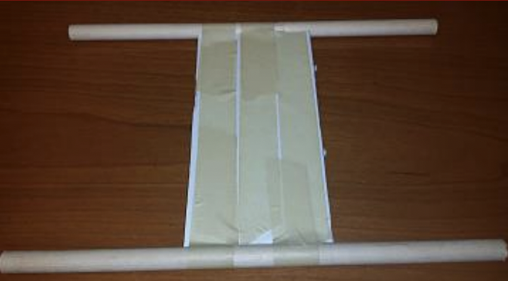

• Cut out two triangles from one end of the foam board
• Place two rubber bands around each of the smaller tubes

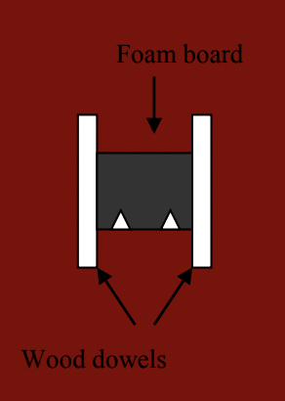
13. Secure small dowels across the big dowels with rubber bands
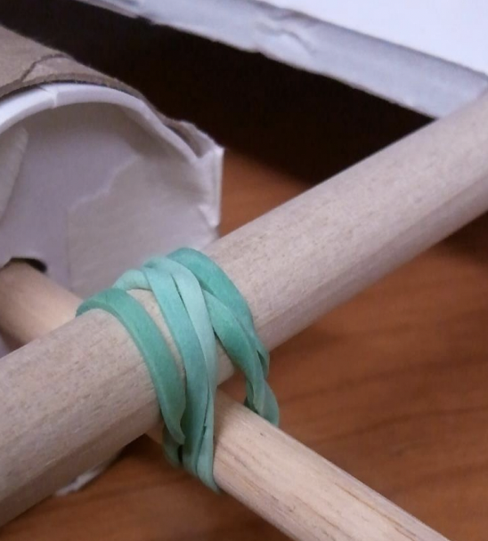
14. Set up a ramp with about a 30 degree incline. The ramp should be about 12” wide.
15. Use masking tape to mark off roadway 12” wide and about 8ft long
16. Have student place the racer on the ramp and let it roll.
17. Mark where the front wheels stop with a piece of tape and the students’ initials
18. Let students make adjustments and modifications to their cars and try again

Tube Car
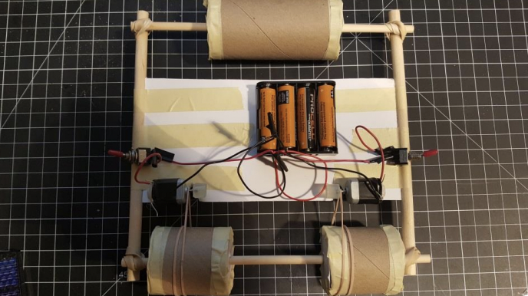

1. Strip both wires from battery holder.
2. Cut and strip 4-5” red wires and 2-5” black wires
3. For the first motor, with the motor stem up and the leads facing you, insert a black wire holder into the left lead of the motor and bend the wire in place.
4. For the second motor, with the motor stem up and the leads facing you, insert a black wire holder into the right lead of the motor and bend the wire in place
5. Insert a red wire into the remaining lead of the first motor and tape both black and red wires in place. Repeat for a
second red wire on the second motor.
6. Twist the free ends of the black wires from both motors with the black wire of the battery holder and tape
7. Glue motors so that stems are over the triangle cut in foam board
8. Glue switches and battery holder in place
9. Cut small pieces of glue sticks and attach to the end of motor stem to keep rubber bands from coming off

Hybrid Tube Car
We will add a solar panel to make the car a hybrid.
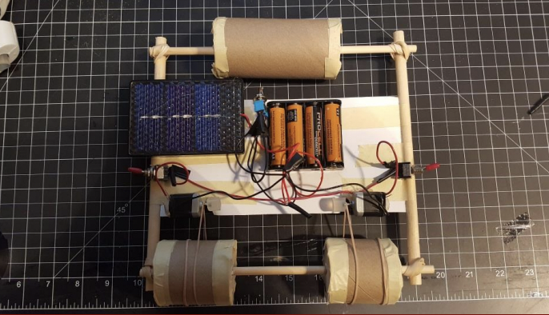

1. Strip both wires from the solar cell
2. Cut and strip a 5” black wire
3. Insert black wire from solar cell to outer post from 3rd switch and bend in place and tape
4. Untwist black wire of battery holder from the two black wires from motors and replace with black wire you just cut and stripped. Twist the new wire and the black motor wires and tape
5. Insert free end of new black wire into center post of toggle switch and bend and tape
6. Insert black wire from battery holder into remaining outside post of toggle switch and tape
7. Remove tape from red wires, twist red wire from solar panel to them and retape
8. We don’t glue the solar panel or the 3rd toggle switch so we can position the solar panel to get maximum
Sunlight
9. Create a moveable mounting for Solar Panel

Arduino Tube Car

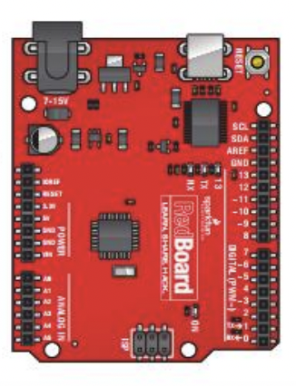

• Use an Arduino with sensors to control Tube Car:
1. To drive autonomously
2. Switch to solar power when there’s enough sunlight
https://www.slideshare.net/xxahmedsakrxx/introduction-to-arduino-16634116

Wrap-up
End the lesson with some final discussions about what students designed/discovered. Connect their activity back to the focus question/problem, real world examples, and STEM careers.

Also include notes about any special cleanup considerations

Lesson Background for Teachers

Standards

NGSS
4-PS3-2 Make observations to provide evidence that energy can be transferred from place to

place by sound, light, heat, and electric currents.

4-PS3-4- Apply scientific ideas to design, test, and refine a device that converts energy from one

form to another.

4-ESS3-1 Obtain and combine information to describe that energy and fuels are derived from

natural resources and their uses affect the environment.

4-PS4-3. Generate and compare multiple solutions that use patterns to transfer information.
3-5-ETS1-1. Define a simple design problem reflecting a need or a want that includes specified

criteria for success and constraints on materials, time, or cost.

3-5-ETS1-2. Generate and compare multiple possible solutions to a problem based on how well each

is likely to meet the criteria and constraints of the problem.

3-5-ETS1-3. Plan and carry out fair tests in which variables are controlled and failure points are
considered to identify aspects of a model or prototype that can be improved.

MS-PS2-2. Plan an investigation to provide evidence that the change in an object’s motion depends

on the sum of the forces on the object and the mass of the object.

MS-PS3-5. Construct, use, and present arguments to support the claim that when the kinetic
energy of an object changes, energy is transferred to or from the object

MS-PS4-3. Integrate qualitative scientific and technical information to support the claim that
digitized signals are a more reliable way to encode and transmit information than analog
signals.

MS-ETS1-1. Define the criteria and constraints of a design problem with sufficient precision to
ensure a successful solution, taking into account relevant scientific principles and
potential impacts on people and the natural environment that may limit possible
solutions.

MS-ETS1-2. Evaluate competing design solutions using a systematic process to determine how well

they meet the criteria and constraints of the problem.

MS-ETS1-3. Analyze data from tests to determine similarities and differences among several design
solutions to identify the best characteristics of each that can be combined into a new
solution to better meet the criteria for success.

MS-ETS1-4. Develop a model to generate data for iterative testing and modification of a proposed

object, tool, or process such that an optimal design can be achieved.

ITEEA 1. Students will develop an understanding of the characteristics and scope of technology.
ITEEA 2. Students will develop an understanding of the core concepts of technology.
ITEEA 3. Students will develop an understanding of the relationships among technologies and the

connections between technology and other fields of study

ITEEA 5. Students will develop an understanding of the effects of technology on the

environment.

ITEAA 6. Students will develop an understanding of the role of society in the development and

use of technology.

ITEAA 9. Students will develop an understanding of engineering design.
ITEAA 10. Students will develop an understanding of the role of troubleshooting, research and
development, invention and innovation, and experimentation in problem solving.
ITEAA 12. Students will develop the abilities to use and maintain technological products and

systems.

ITEAA 16. Students will develop an understanding of and be able to select and use energy and

power technologies.

ITEAA 18. Students will develop an understanding of and be able to select and use transportation

technologies.
CCSS.Math.Content.4.MD.A.1

Know relative sizes of measurement units within one system of units including km, m, cm; kg, g; lb, oz.; l,
ml; hr, min, sec. Within a single system of measurement, express measurements in a larger unit in terms
of a smaller unit.
CCSS.Math.Content.4.MD.A.2
Use the four operations to solve word problems involving distances, intervals of time, liquid volumes,
masses of objects, and money, including problems involving simple fractions or decimals, and problems
that require expressing measurements given in a larger unit in terms of a smaller unit. Represent
measurement quantities using diagrams such as number line diagrams that feature a measurement
scale.
CCSS.Math.Content.4.MD.A.3
Apply the area and perimeter formulas for rectangles in real world and mathematical problems
CCSS.Math.Content.4.MD.C.5
Recognize angles as geometric shapes that are formed wherever two rays share a common endpoint,
and understand concepts of angle measurement:
CCSS.Math.Content.4.MD.C.5.a
An angle is measured with reference to a circle with its center at the common endpoint of the rays, by
considering the fraction of the circular arc between the points where the two rays intersect the circle.
An angle that turns through 1/360 of a circle is called a "one-degree angle," and can be used to measure
angles.
CCSS.Math.Content.4.MD.C.5.b
An angle that turns through n one-degree angles is said to have an angle measure of n degrees.
CCSS.Math.Content.4.OA.A.2
Multiply or divide to solve word problems involving multiplicative comparison, e.g., by using drawings
and equations with a symbol for the unknown number to represent the problem, distinguishing
multiplicative comparison from additive comparison.1
CCSS.Math.Content.4.OA.A.3
Solve multistep word problems posed with whole numbers and having whole-number answers using the
four operations, including problems in which remainders must be interpreted. Represent these
problems using equations with a letter standing for the unknown quantity. Assess the reasonableness of
answers using mental computation and estimation strategies including rounding.

CCSS.Math.Content.5.MD.A.1
Convert among different-sized standard measurement units within a given measurement system (e.g.,
convert 5 cm to 0.05 m), and use these conversions in solving multi-step, real world problems.
CCSS.Math.Content.6.RP.A.1
Understand the concept of a ratio and use ratio language to describe a ratio relationship between two
quantities.
CCSS.Math.Content.6.EE.A.2.c
Evaluate expressions at specific values of their variables. Include expressions that arise from formulas
used in real-world problems. Perform arithmetic operations, including those involving whole-number
exponents, in the conventional order when there are no parentheses to specify a particular order (Order
of Operations
CCSS.Math.Content.7.EE.B.3
Solve multi-step real-life and mathematical problems posed with positive and negative rational numbers
in any form (whole numbers, fractions, and decimals), using tools strategically. Apply properties of
operations to calculate with numbers in any form; convert between forms as appropriate; and assess
the reasonableness of answers using mental computation and estimation strategies.

Safety Procedures

• Caution should be exercised with cutting utensils (scissors, X-acto blade).
• Students should be careful with glue gun.
• Students should use caution when using hammer and nails.
• Proper safety procedures and equipment should be used for drill.

